Travel Exploration App

Introduction
Project Name: Travel Exploration App
Goal: The app will offer personalized recommendations and
seamless tools for discovering and planning trips.
Role: UX/UI Designer and Developer
Tools Used: Figma, Adobe XD
Team members:
1.K MATHESH KUMAR(TL)
2.A ABIBRISCKILLA
3.L ANITHA
4.K YUVARAJ
5.P SUNDAR

Problem Statement
Many travelers struggle to discover unique destinations and plan
trips efficiently Existing travel apps often overwhelm users with cluttered
interfaces and generic suggestions.This leads to frustration and reduced
motivation to explore new places.There is a need for an intuitive app that
simplifies trip planning while inspiring authentic exploration.

User Research
1.User research revealed that travelers seek personalized
recommendations based on their interests and budget.
2. Many users find current travel apps confusing and time- consuming to
navigate.
3. They desire visual inspiration, easy itinerary planning, and real-time
local insights.
4. Interviews and surveys showed a preference for simplicity,
personalization, and community-driven content.

Information Architecture
1.Home – Explore destinations, featured trips, and personalized
suggestions.
2. Discover – Search by location, interest, or theme; view maps and
recommendations.
3. Plan Trip – Create itineraries, save places, and manage travel details
4.Community – Share experiences, reviews, and travel photos.
5.Profile – Manage preferences, saved trips, settings, and account info.

User Flow / Journey
1.The user opens the app and signs in to view personalized travel
suggestions.
2.They explore destinations through interactive maps and curated
recommendations.
3.After selecting a destination, they create and customize their trip
itinerary.
4.Finally, they save or share the trip and receive real-time updates during
travel.

Wireframes
1.Home: Search bar, featured destinations, and personalized
suggestions.
2.Discover: Map view with filters and destination cards.
3.Plan Trip: Itinerary layout with add/remove activities.
4.Profile: User info, saved trips, and settings options.

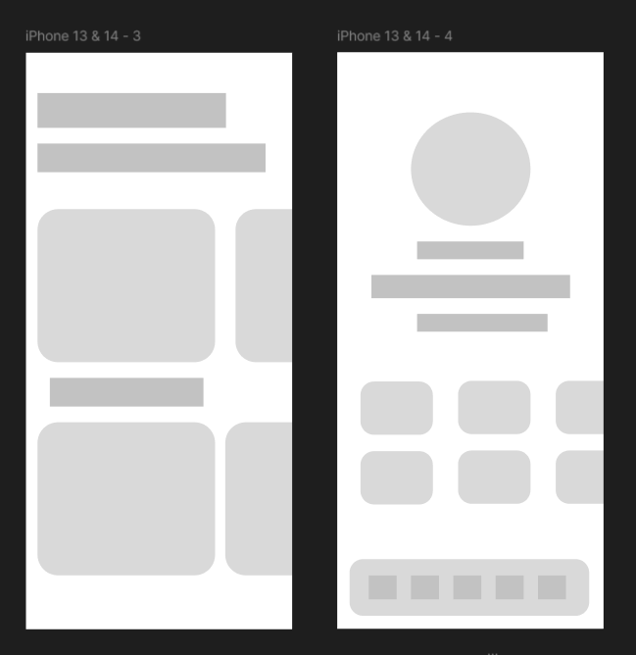

UI Design
- Color Palette: Soft blues and warm neutrals to evoke travel calmness
and trust.
2.Typography: Clean, modern sans-serif fonts for readability.
3.Icons & Imagery: Minimal icons and high-quality destination photos.
4.Layout: Intuitive navigation with clear buttons and spacious, visual
Design.

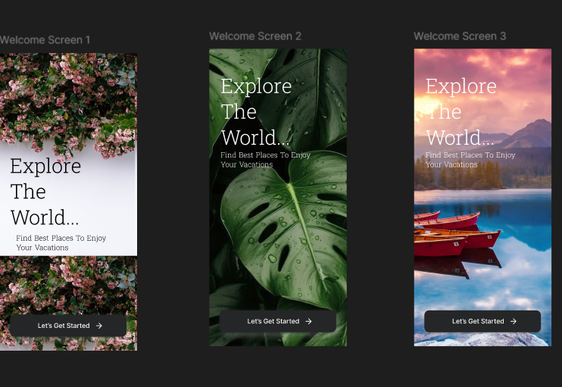

Prototype & Interactions
1.Interactive Prototype: Clickable screens showing the complete user
journey from exploration to trip planning.
2.Transitions: Smooth slide and fade animations between sections for a
fluid experience.
3.Microinteractions: Subtle feedback for taps, likes, and saving trips to
enhance engagement.
4.Navigation: Bottom tab bar enables quick access to Home, Discover,
Plan, and Profile.

Conclusion
1.The app makes travel discovery and planning simple and engaging.
2.Personalized recommendations and intuitive design enhance the user
experience.
3.It inspires exploration while keeping navigation and trip management
effortless.

